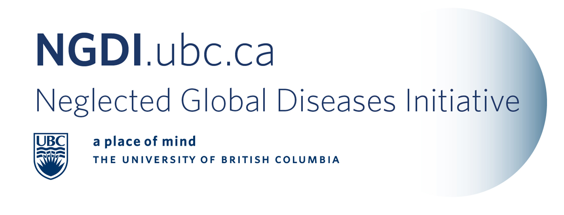

E-newsletter Contents: February 1, 2011
NGDI-UBC News
Funding opportunities
Conferences and Announcements
Call for papers and abstracts
Journals, articles, reports and news
  - General
  - Guinea Worm
  - Malaria
  - Leishmaniasis
  - Tuberculosis

§
Member News
- NGDI Member Elected to WHO Committee - Steve Morgan
After being nominated by Health Canada last fall, I have recently been accepted as a member of the WHO Consultative Expert Working Group (CEWG) on Research and Development: Financing and Coordination. The committee is a time-limited advisory body that is asked to “…examine current financing and coordination of research and development, as well as proposals for new and innovative sources of funding to stimulate research and development related to Type II and Type III diseases and the specific research and development needs of developing countries in relation to Type I diseases…” (World Health Assembly 2010).
Background details are in the attached PDF and information about the nominated committee members can be found here: http://www.who.int/phi/cewg_rdfc_nominations/en/index.html

NGDI-UBC News

- Getting involved with the NGDI-UBC – Faculty, Students and Staff
The best way to start your involvement with the NGDI-UBC is to fill out our NGDI-survey so that we know what your interests are. We use this survey to invite participants to our research cluster meetings, find out about your projects and whether you’d like to be included on our website. We appreciate your interest!

- Celebrate Research Week – Creating Change, Creating Impact
Date: March 4, 2011
Time: Noon – 2:00 pm Seminar, Noon – 3:30 pm Poster Competition
Location: Life Sciences Centre Room 3, 2350 Health Sciences Mall, (seminar) Poster Competition in West Atrium.
This event is co-sponsored by the NGDI-UBC and Universities Allied for Essential Medicines, UBC Chapter

Seminar Speakers:
- Dr. Lindsay Eltis, Professor, Microbiology & Immunology and Head, Centre for TB Research
- Dr. Rebecca Goulding, Universities Allied for Essential Medicines
- Mr. Angus Livingstone, Managing Director, University‐Industry Liaison Office
- Dr. Peter von Dadelszen, Associate Professor, Obstetrics and Gynaecology and (recently awarded $7 million Bill & Melinda Gates Foundation grant)

- Distinguished Lectureship Seminar Series – Dr. Michael Hayden
The inaugural NGDI – Distinguished Lectureship Seminar Series featuring Dr. Michael Hayden, Director of the Centre for Molecular Medicine and Therapeutics was a great success! See this link for pictures and more details.
Over 90 faculty, staff, and students enjoyed a one hour talk by Dr. Hayden as he highlighted the great work that he has been doing in South Africa and with his international Ripples of Hope Award.
The members of the working group for the NGDI thank Dr. Hayden for taking the time out of his very busy schedule to help inaugurate our new Distinguished Lectureship Seminar Series. Dr. Kish Wasan representing the group presented Dr. Hayden with a gift of appreciation for his talk.

[Top]

Funding Opportunities

- Grand Challenges Canada – Canadian Rising Stars Challenge
Applicants must:
• Be no more than 10 years from having completed a PhD or a health professional degree at the time of taking up the award;
• Be affiliated with a Canadian non-profit organization, for-profit company, or other recognized institution capable of supporting the proposed activities and administering grants;
• Be willing to engage the public on their project and, more generally, on global health topics;
• Have a co-investigator in a low- or middle-income country. This is desired from the proof-ofprinciple stage, and will be required for the scale-up phase (see more detail below);
• Have the support of a mentor, who will provide guidance and facilitate career development.

Deadline: March 7th, 2011

- CANADA-HOPE Scholarship Program- Fellowship Awards (2011-2012)
Application deadline: March 31st, 2011

The primary goal of the CANADA-HOPE Scholarship Program is to further develop international collaborative efforts between researchers. The short term goal is to enable promising individuals to be mentored by prominent Canadian researchers. The long term objective of the Program is to enable promising scientists and clinicians from Low and Middle Income Countries (LMIC), as identified by the Canadian International Development Agency (CIDA) and the United Nations (UN), to be exposed to some of the best science, laboratories and training environments in Canada. This round will focus on sub continental South Asia and Sub-Saharan Africa.

Value and term: The maximum amount awarded for a single award is $174,000 for up to four years:

* Trainee stipend: $40,000 or $50,000 per annum. The stipend level is related to the major degree, licensure (where applicable) and experience of the applicant. Stipends are valued in Canadian dollars and are taxable.
* This award is non-renewable.

- IDRC Canadian International Food Security Research Fund

Call for Concept Notes – Deadline March 23, 2011
Budget: $1M - $5M
30-mo. Maximum project duration; early 2012 start date
Online application available Feb 9th.

**IF THERE IS INTEREST IN COLLABORATING WITH ANOTHER UBC GROUP TO SUBMIT A JOINT PROPOSAL, PLEASE CONTACT MY OFFICE – THANKS. JACQUELINE**

The goal of the Fund is to foster the development of more productive and environmentally sustainable agricultural systems that increase food security and enhance nutrition in developing countries (see list below).
The two key objectives are to:
a) Increase food security in developing countries through investments in applied research for agricultural productivity and nutrition; and
b) Harness Canadian expertise and knowledge in food security related science and technology to develop solutions with and for the developing world.

IDRC and CIDA are especially interested in supporting innovative research with the potential for breakthrough results that could be effectively scaled up and easily adopted by small-holder farmers, food processors, post-harvest handlers, and other value chain actors to improve food security in developing countries.

Each partnership must include at least Canadian organization, and at least one organization based in one of the eligible countries in the South. Proposed research should clearly address real, practical development challenges related to the objectives of the Fund, targeting the poor and most vulnerable groups, and with the potential to generate applied research results within the lifetime of the research project and potential development impacts within three years after the project ends.

This call will support applied field and/or laboratory research projects with potential to generate high impact and innovative results for agriculture, nutrition, and food in developing countries, with particular impact on the poor (including women and vulnerable groups). Research must be completed within the timeframe of the project (30 mo.), and should have the potential for development impacts within three years after the project ends. Longer-term research (e.g., breeding, farming systems, etc.), weather-dependant research, and intensive participatory research will need to be clearly justified to ensure that work can be completed and results demonstrated within 30 months.
Basic, fundamental, purely theoretical, and/or policy research will not be considered.

Concept notes comprise summary information, 6-pg research project description, project overview, consolidated budget, CVs & Letters of Endorsement.

The Office of the VP Research & International provides consultation and support in the development of international research proposals. Please contact our research officer below.

Jacqueline Smit, Senior Officer, International Research Initiatives, Office of the Vice President Research & International, University of British Columbia
T. 604-822-8136, jacqueline.smit@ubc.ca

[Top]

Conferences and Announcements

- World TB Day 2011, March 24th, 2011
TB awareness day at the University of British Columbia
Following the success of the last year’s first World TB Day at the University of British Columbia (WTBD-UBC), we are excited to announce the second edition of this event.
WTBD-UBC 2011 will raise awareness about tuberculosis in the university community and among the general public. TB remains an epidemic in much of the world, causing the deaths of almost 2 million people each year. In Canada, the incidence of TB is particularly high among First Nations people and is on the rise again in the North. In Vancouver, TB is a growing concern in the Downtown East side (DTES).
A poster session and short seminars will be part of the day’s event in the Life Science Centre at UBC.
Keynote speaker: Pam Chedore, Head of Mycobacteriology at the Central Public Health Laboratory, Ontario and international consultant for laboratory capacity development is scheduled.
An outreach community event will be also held in the Downtown Eastside (United Church). In order to plan for catering, we need an estimate of the number of people who will be attending. Confirmations should be sent ASAP to Santiago Ramón-García at ramon@interchange.ubc.ca.

- 2nd Annual Conference on Surgery & Anesthesia in Uganda

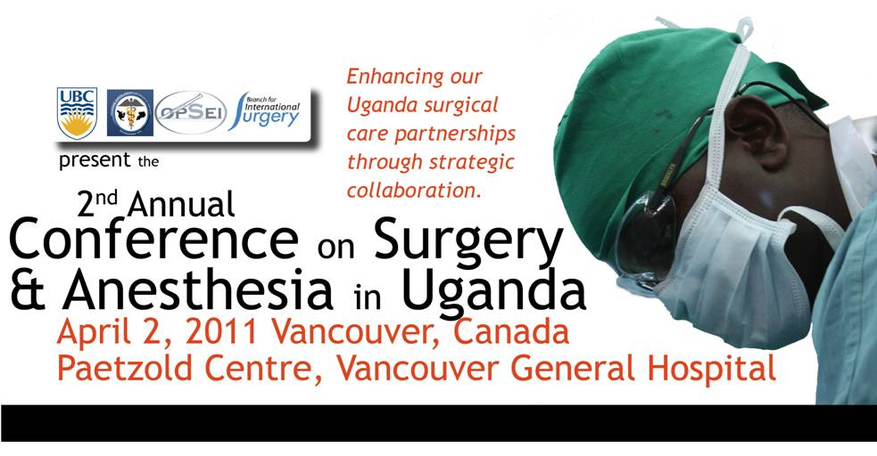

Click here for the program and click here to register.
If you would like to participate in the conference through a Skype video link, please email Nathan O’Hara at nohara@cw.bc.ca.

- International Development Week (IDW)
This event is held annually and this year, is taking place from February 7th to February 11th. IDW highlights the work of Canada's development community.
The Simon K.Y. Lee Global Lounge & Resource Centre is celebrating IDW by providing an opportunity for UBC students to:
- increase the awareness of the role many Canadians play in international development;
- learn more about life in developing countries; and
- find out how they can become global citizens, actively involved in international development.
Join us at the Global Lounge & Resource Centre (2205 Lower Mall, Building 1) for events taking place throughout the week of February 7th to 11th.

Monday, February 7th: 5pm to 7pm
The Development of International Development
International development is a concept that lacks a universally accepted definition. Dr. Michael Seear and Dr. Jennifer Chun will lead a discussion about different perspectives on the history of development and issues it faces today.

Tuesday, February 8th: 5pm to 7pm
A Day in the Life of the International Humanitarian
Join us for an open conversation with humanitarians that have worked both internationally and here in Canada. Our panelists include those who work in the health, engineering, agricultural and business fields. We will also have panelists currently working in the field chat with us through skype.
Find out what a true day in the life of an international humanitarian is all about and how you can get involved in this type of work.

Thursday, February 10th: 5pm to 7pm
The Impact of Journalism on International Development
Is what you see and read about on the news really the whole story? Does the media really represent the “community voice”? Are we really hearing both sides of the story? Join the Ethics of International Engagement & Service Learning (EIESL), STAND, and the Fiji Awareness Network for a dialogue about how "crisis politics" and “Otherness” is portrayed in the media today.
For more information on these events and the Global Lounge – check out our blog!
Learn more about International Development Week more generally at: www.acdi-cida.gc.ca/idw.

- The McLaughlin-Rotman Centre for Global Health is launching its annual summer student program for 2011!

We are looking for individuals to work in the areas of Grand Challenges Canada and Ethics. To apply please send a cover letter outlining your interest in one or more of the focus areas, relevant skills and your summer availability, a CV/resume, two letters of reference (at least one from an academic source) and a writing sample to info@mrcglobal.org. You can also fax your application to (416) 978-6826. Only candidates chosen for interviews will be contacted.
The deadline for submissions is March 15, 2011.
The McLaughlin-Rotman Centre for Global Health is based at University Health Network and University of Toronto. We develop innovative global health solutions and help bring them to scale where they are most urgently needed. The McLaughlin-Rotman Centre for Global Health hosts Grand Challenges Canada. For further information, please visit our website at www.mrcglobal.org, and follow us on Twitter, Facebook, and YouTube
[Top]

Call for Papers or Abstracts

- Celebrate Research Week – Creating Change, Creating Impact – Deadline February 28, 2011

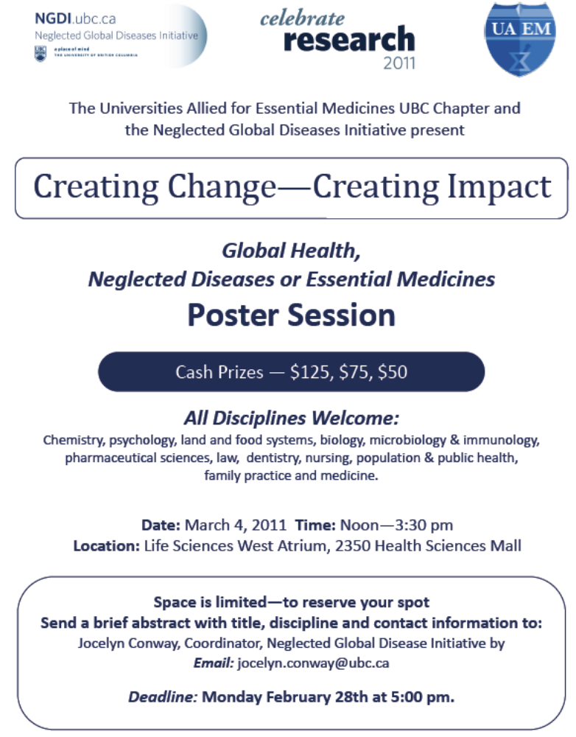
- World TB Day 2011, March 24th – $250.00 prize for best poster by a trainee.
TB awareness day at the University of British Columbia – Deadline: March 12th, 2011
A poster session, short seminars, and a talk by a keynote speaker will be part of the day’s event in the West Atrium in the Life Science Centre at UBC. We are seeking abstracts showcasing the local efforts in the fight against TB: from basic scientific to clinical research and social health approaches.
Please send your abstracts to the following address:
E-mail: ramon@interchange.ubc.ca
Submissions should include a title, authors, affiliation and an abstract not to exceed 250 words. Posters that have recently been used at another meeting are welcome. For more information on the event, see the preliminary program.

- WHO/PLoS Collection “No Health Without Research”: A Call for Papers
The World Health Report (WHR) for 2012 will be on the theme of “No Health without Research”. This flagship report from WHO will, for the first time in its history, focus on research for better health. The primary target audience of the report will be ministers of health in the WHO member states, and the goal of the report is to provide new ideas, innovative thinking, and pragmatic advice for member states on how to strengthen their own health research systems. The report will have the three following aims.

- To show that research is important for meeting health needs and improving health outcomes;
- To encourage countries to therefore invest more resources in developing and strengthening their national health research systems;
- To argue that countries should not see research as an expense or as an afterthought, but as an investment for a better, healthier future.

This is new initiative for PLoS and WHO. We look forward to collaborating on this initiative and hope it will encourage researchers to submit to PLoS the very best examples of research underpinning health care. More information is available here.
[Top]

Journals, Articles, Reports and News

- General

Continuing challenge of infectious diseases in India Lancet Series on Health Care in India

The ongoing debate over R&D output, Tropika.net
“What happens after a paper is published is as important as what occurred before it was published.” That is one of the core concepts of the journal PLoS ONE, an on-line, open-access resource published by the non-profit Public Library of Science. And it was in evidence last July, when the authors of a pair of peer-reviewed articles on research and development (R&D) output over the past several decades engaged in a post-publication debate through comments posted on the PLoS ONE site.

GHFN Launches Pioneering Video Newsgathering Operations Worldwide PRWeb

After more than a year of planning and trial productions in Africa and Asia, Global Health Frontline News (GHFN) is now assigning video newsgathering crews worldwide to cover major global health stories in partnership with selected broadcasters and Internet platforms. Videos on neglected diseases are available here: http://cieloproductions.org/CieloSite/Home.htm.
Integrated Implementation of Programs Targeting Neglected Tropical Diseases through Preventive Chemotherapy: Proving the Feasibility at National Scale, Tropical Medicine & Hygiene
In 2006, the United States Agency for International Development established the Neglected Tropical Disease (NTD) Control Program to facilitate integration of national programs targeting elimination or control of lymphatic filariasis, onchocerciasis, schistosomiasis, soil-transmitted helminthiasis and blinding trachoma.

Federal Research Center Will Help Develop Medicines, New York Times
The Obama administration has become so concerned about the slowing pace of new drugs coming out of the pharmaceutical industry that officials have decided to start a billion-dollar government drug development center to help create medicines.

Working towards an improved rotavirus vaccine for the developing world, Wellcome Trust press release
The MSD Wellcome Trust Hilleman Laboratories announced today that the organisation’s first project will be a feasibility study into how new technologies might be used to develop a rotavirus vaccine designed specifically with developing country needs in mind. Formulations based on dissolving thin strips or granules will be examined for their potential to improve product stability, ease of use, transportation and affordability.

MDG Progress Index: Gauging Country-Level Achievements, Center for Global Development
In a recent CGD working paper Who Are the MDG Trailblazers? A New MDG Progress Index, CGD research fellow Ben Leo and Julia Barmeier assess individual country performance against eight core MDG targets (extreme poverty, hunger, education, gender, child mortality, maternal mortality, HIV/AIDS, and water). For each target, the Index compares a country's actual performance over time with the rate of improvement needed to reach the target by 2015.

To better present the results of the paper, this interactive MDG web tool illustrates each individual country's progress towards the highly ambitious MDG targets. The tool includes MDG Progress Scorecards for each country, which include performance trajectories for each core target. In addition, we have provided supplementary map overlays for those MDGs with absolute performance targets (education and gender), which are widely considered as biased and unfair to countries starting off a low-base. These alternative measures illustrate each country's average annual progress - arguably a much more realistic measure of real-world improvements. Finally, we've included the complete underlying dataset to provide our users with even greater workability.

McGill Awarded $1-Million Grant to Address Debilitating Parasitic Diseases in the Developing World, offering a Canadian solution to a Pressing Global Health Challenge, CNW
McGill University and McGill University scientist Dr. Timothy Geary received a $1-million grant today for landmark research into addressing parasitic diseases through medicines derived from African biodiversity. Grand Challenges Canada, Canada's International Development Research Centre, The Canadian Institutes of Health Research and the Bill & Melinda Gates Foundation have joined together to support this important research which provides a significant Canadian contribution to a serious global health issue.

Health biotechnology innovation on a global stage, Nature News Microbiology
With increasing globalization, infectious diseases are spreading faster than ever before, creating an urgent need for international collaboration. The rise of emerging economies has changed the traditional collaborative landscape and provided opportunities for more diverse models of collaboration involving developing countries, including North–South, South–South and North–South–South partnerships. Here, we discuss how developing countries can partner with other nations to address their shared health problems and to promote innovation. We look specifically at what drives collaborations and at the challenges that exist for them, and we propose actions that can strengthen these partnerships.
- Guinea Worm

Southern Sudan's votes could kill an ancient disease New Scientist
"There is huge excitement and euphoria here," says Makoy Samuel Yibi, phoning from Juba in Southern Sudan. There, this week's referendum vote looks set to divide Sudan into independent north and south countries, potentially ending decades of civil war. The result is largely a foregone conclusion: independence will be announced officially in February. At the same time, as it does every February, Southern Sudan will report the year's first cases of a painful and ancient disease: guinea worm. But this could be the last time. Besides creating a new country, this week's vote could make guinea worm the second human disease – after smallpox – to be eradicated. War and neglect have made Southern Sudan the worm's last stronghold. "If the political situation remains stable, we can stop it in 2012," says Makoy, director of the Southern Sudan ministry of health's guinea worm eradication programme.
- Malaria

WHO, Roll Back Malaria Partnership Launch Initiative To Contain Artemisinin-Resistant Malaria, WHO Report
The WHO and Roll Back Malaria partnership (RBM) on Wednesday launched an initiative to "stop a form of drug-resistant malaria from spreading from Southeast Asia to Africa, where millions of lives could be at risk," Reuters reports. "It would cost about $175 million a year to contain and prevent the global spread of the artemisinin-resistant parasite which first emerged along the Thai-Cambodian border in 2007, the United Nations agency said," according to the news agency (Nebehay, 1/12).

GSK malaria vaccine shows long-lasting protection, Reuters
LONDON, Jan 14 (Reuters) - An experimental malaria vaccine from GlaxoSmithKline provides African children with long-lasting protection, though its effectiveness declines slightly over time, according to trial data published on Friday. The Lancet Journal Article Abstract is available here.
- Leishmaniasis

Mosquito nets fail to prevent against kala azar disease, European Commission

Long-lasting insecticidal nets were an important breakthrough in malaria prevention. However, they do not offer protection against all diseases transmitted by insect bites, according to a new international study. This research is an outcome of the KALANET ('Efficacy, acceptability and cost-effectiveness of long lasting insecticidal nets in the prevention of Kala-azar') project, which clinched EUR 2.11 million under 'International cooperation activities' (INCO) Activity of the EU's Sixth Framework Programme (FP6). The study was presented in the British Medical Journal.

Comparison of short-course multidrug treatment with standard therapy for visceral leishmaniasis in India: an open-label, non-inferiority, randomised controlled trial, The Lancet
Improved treatment approaches are needed for visceral leishmaniasis. We assessed the efficacy and safety of three potential short-course combination treatments compared with the standard monotherapy in India.

- Tuberculosis
CDD Extends Gates Grant, CDD
The Bill & Melinda Gates Foundation recently extended its previous grant to CDD to create a novel database to spark collaborative efforts to discover more effective drugs against tuberculosis (TB). Over the past two years, the CDD TB database (CDD TB DB) has integrated the efforts of academic, non-profit, government and corporate laboratories distributed across the globe to accelerate their efforts to discover new therapies against this deadly disease.

[Top]

Neglected Global Diseases Initiative at the
University of British Columbia
Tel: 604-827-5348
Cell: 604-218-4849
Email: jocelyn.conway@ubc.ca
Web: www.ngdi.ubc.ca

