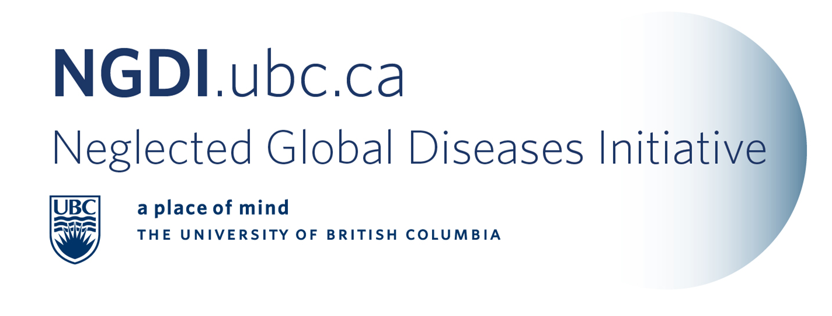

E-newsletter Contents: March 1, 2011
NGDI-UBC News
Funding opportunities
Conferences and Announcements
Call for papers and abstracts
Journals, articles, reports and news
  - General
  - Dengue
  - Malaria

Member News
- NGDI Member Update – Annalee Yassi
Joint WHO-ILO-UNAIDS Policy Guidelines on Improving Health Worker Access to HIV and TB Prevention, Treatment, Care and Support services. In Geneva, on November 25, 2010
Dr. Yassi was lead consultant for this triple UN Agency production of guidelines for HIV and TB prevention for health workers. All three UN agencies, as well as their regional and country counterparts note that protecting health workers, countries would ensure that those providing health services are themselves healthy, which will in turn facilitate people’s rights of access to quality health services worldwide. The Guidelines, as well as the Technical Documents and Systematic Review can be found at: http://www.who.int/occupational_health/publications/hiv_tb_guidelines/en/index.html

In Quito, on November 29th 2010, the Pan American Health Organization formally launched the Spanish version of on-line tools created by NGDI team member, Dr. Annalee Yassi, with colleague Dr. Elizabeth Bryce from Vancouver Coastal Health, along with international collaborators, to protect health workers from infectious diseases. These tools, widely used now across the Americas and beyond, are available at www.ghrpinnovation.com.

March 2011, a certificate program in Implementation and Evaluation of Workplace-based Programmes for HIV and Tuberculosis Prevention and Care will be launched in Bloemfontein, South Africa. This is an international collaboration between UBC, under the direction of NGDI member Dr. Annalee Yassi, and the University of the Free State in South Africa. The initiative is funded by the Canadian HIV Vaccine Initiative, of the Global Health Research Initiative, administered by the International Research Development Centre.

- Killam Research Award – Lindsay Eltis
The NGDI congratulates Dr. Lindsay Eltis for his Killam Research Award, which were announced this month.

NGDI-UBC News
- CDRD Partners with NGDI-UBC: To Develop New Interventions for Neglected Global Diseases
The Centre for Drug Research and Development (CDRD) and the Neglected Global Diseases Initiative at the University of British Columbia (NGDI-UBC) today announced that they will collaborate on developing interventions for neglected global diseases and ensuring their delivery to those in need.
“We hope to leverage CDRD’s drug development platform and expertise to accelerate the development of much-needed therapeutics that address neglected global diseases, while at the same time NGDI-UBC will ensure reasonable, fair and affordable access for developing countries,” said Dr. Kishor M. Wasan, Director and Co-Founder, NGDI-UBC and Professor, Faculty of Pharmaceutical Sciences, UBC. “Any joint project approved by CDRD will be developed within the context of UBC’s Global Access Principles, which was an important criteria for our group,” added Dr. Wasan.
“NGDI-UBC brings to CDRD an extensive network of expertise that extends across broad disciplinary boundaries. This partnership will augment our ongoing drug development efforts, including some projects already underway with world leading scientists in the area of neglected global diseases,” said Karimah Es Sabar, Senior Vice President, Business & Strategic Affairs at CDRD.
For example, Drs. Bill Mohn and Lindsay Eltis – both professors from the Department of Microbiology & Immunology at UBC – are jointly working on a project that addresses Tuberculosis (TB), which has been identified by the World Health Organization as a critical neglected global disease. Their development work on the “Identification of small molecule inhibitors of cholesterol degradation as a therapeutic approach to the treatment of Tuberculosis” has been enabled by the drug development platform at CDRD.
“Collaborating with CDRD has provided Dr. Eltis and I with the access to the drug development infrastructure and expertise required to turn out a bench-top assay into a high-throughput screen,” said Dr. Bill Mohn.
CBC Radio interview: Dr. Kishor Wasan spoke to CBC Radio on this new partnership on February 16th, 2011.

- Year of Science Funding received for NGDI-UBC/UAEM Celebrate Research Event
A grant of $1,500 was awarded to the NGDI / UAEM for the Creating Change, Creating Impact event (see below). This additional funding will provide a video recording of the event and advertising in the Vancouver Courier. This funding is in addition to the $1,000 contributed by the Faculty of Pharmaceutical Sciences.

- Getting involved with the NGDI-UBC – Faculty, Students and Staff
The best way to start your involvement with the NGDI-UBC is to fill out our NGDI-survey so that we know what your interests are. We use this survey to invite participants to our research cluster meetings, find out about your projects and whether you’d like to be included on our website.

We appreciate hearing what is happening with you and your research. Please feel free to submit new articles and announcements to Jocelyn for inclusion in the newsletter and/or end of year review.

- Vaccine Research Cluster Meeting held on February 2nd, 2011.
The first vaccine research cluster meeting was attended by eleven members. The main topics were: researcher updates, the good current vaccine funding climate and finding a strong collaborative project to develop. This group was mostly representative of the discovery and development groups, however, one member represented access to vaccines as well.

- Celebrate Research Week – Creating Change, Creating Impact
Seminar location: Life Sciences Institute Auditorium 3, 2350 Health Sciences Mall
Date: Friday, March 4, 2010 Time: 12:00 pm to 2:00 pm Free admission, snacks available.
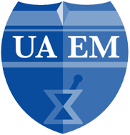

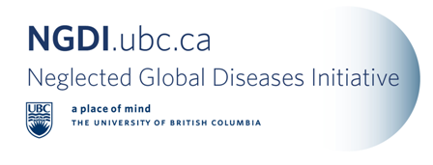

Program
Facilitator: Dr. Kishor Wasan, Professor, Faculty of Pharmaceutical Sciences; CIHR/iCo Therapeutics Research Chair in Drug Delivery for Neglected Global Diseases

There will be time for a few questions in between each speaker:
12:00 – 12:30 pm Dr. Lindsay Eltis, Professor, Microbiology & Immunology, and
Head of Centre for Tuberculosis Research at UBC
Title: Tuberculosis: the modern face of an ancient scourge.

12:30 – 1:00 pm—Dr. Rebecca Goulding, Universities Allied for Essential Medicines
Title: Open Innovation and Neglected Diseases

1:00 – 1:30 pm Mr. Angus Livingstone, Managing Director, University-Industry Liaison Office
Title: Global Access Principles: Dream versus Reality

1:30 – 2:00 pm Dr. Peter von Dadelzsen, Associate Professor, Obstetrics and Gynaecology
Title: Reducing Maternal Mortality in Lower- Middle-Income Countries.

Graduate Student Poster Session (Atrium) 12:00 pm – 3:30 pm. Judging 2:15 pm – 2:45 pm
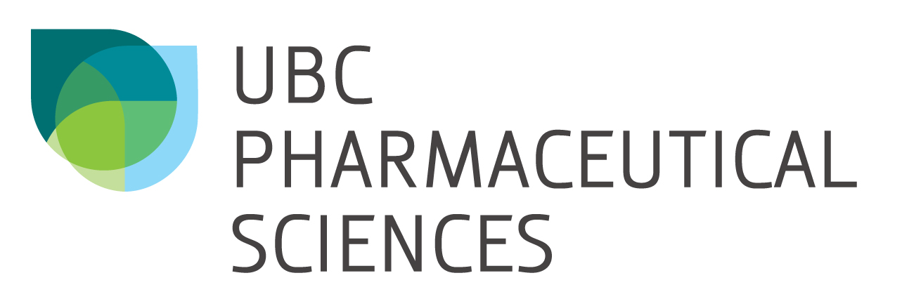

[Top]

Funding Opportunities

- Upcoming Deadlines
Grand Challenges Canada – Canadian Rising Stars Challenge
Deadline: March 7th, 2011

The Martha Piper Research Fund
Deadline: March 15, 2011

The McLaughlin-Rotman Centre for Global Health is launching its annual summer student program for 2011
Deadline for submissions is March 15, 2011. For further information, please visit our website at www.mrcglobal.org.

IDRC Canadian International Food Security Research Fund
Call for Concept Notes – Deadline March 23, 2011 Contact: Jacqueline Smit: T 604-822-8136 or jacqueline.smit@ubc.ca

CANADA-HOPE Scholarship Program- Fellowship Awards (2011-2012)
Application deadline: March 31st, 2011
[Top]

Conferences and Announcements

- Dr. Philip Cooper at Michael Smith Auditorium, Wednesday, March 16 at 3:30 pm
Title: Effects of chronic helminth infections on allergy and allergic disease
Co-sponsored by the Michael Smith Laboratories and the Department of Microbiology & Immunology

Dr. Cooper is investigating the role of early exposures to helminth parasites on the development of immunity and inflammatory diseases in a cohort of 2,400 children (the ECUAVIDA birth cohort) followed from birth in Esmeraldas Province in Ecuador. This is being conducted in parallel with studies of the effects of migration and changes in environmental exposures (including helminths) associated with migration from rural to urban areas on the development of asthma in a migrant population in Esmeraldas Province. These Wellcome Trust- sponsored studies will help us understand the causes of
the high prevalence of inflammatory diseases such as asthma in Latin America

- World TB Day 2011, March 24th, 2011
TB awareness day at the University of British Columbia
Morning speakers include:
Intro NGDI-UBC - Kishor M. Wasan, R. PH, Ph.D., UBC
Katherine Yam, CTBR - "Characterization of HsaC, a ring-cleaving dioxygenase, in the cholesterol catabolic pathway of M. tuberculosis."
Victoria J Cook, MD, FRCPC. BC CDC – "Tuberculosis Control in the Aboriginal Communities of British Columbia"
Dennis Wong, CTBR – "Interplay between Mycobacterium tuberculosis tyrosine phosphatase and host cellular pathways"
Kevin Elwood, MD, FRCPC BC CDC – “TB- Festina lente?”
Prof. Robert E.W. Hancock, Ph.D., UBC - “Systems Biology approaches to understand infections. Designing new therapeutic and vaccine approaches for TB”
A poster session and short seminars will be part of the day’s event in the Life Science Centre at UBC.
Keynote speaker : Pam Chedore, Head of Mycobacteriology at the Central Public Health Laboratory, Ontario and international consultant for laboratory capacity development is scheduled.
An outreach community event will be also held in the Downtown Eastside (United Church). In order to plan for catering, we need an estimate of the number of people who will be attending. Confirmations should be sent ASAP to Santiago Ramón-García at ramon@interchange.ubc.ca.

- Save the Date: The Global Indigenous Conference at UBC: April 1-2, 2011
Location: First Nations House of Learning

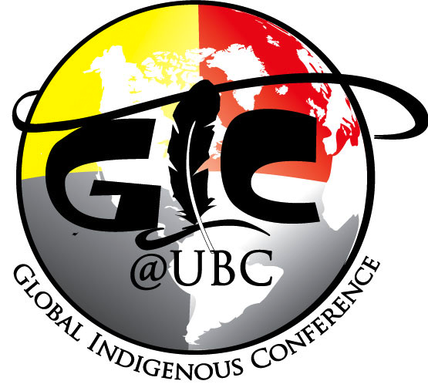
The theme of this event is Indigenous peoples and globalization. Both Indigenous and non-indigenous students at UBC have collaborated to create this initiative. Attending will be various Indigenous activists, academics, scholars and youth. This conference includes discussion panels, workshops, presentations, networking, and open dialogue on the following topics:
Sustainability
Resource and Land Rights
Indigenous Health
Indigenous Women’s Issues
Education
Language and Cultural Revitalization
Elder/Youth Engagement
We hope to see you there

For more information please contact gic.ubc.2011@gmail.com

- Save The Date: Global Health Conference, Montreal, November 13-15, 2011
The Global Health Education Consortium (GHEC), the Consortium of Universities for Global Health (CUGH) and the Canadian Society for International Health (CSIH) will come together from November 13-15 to hold a joint global health conference in Montreal, Canada. Harnessing the energy of these three leading societies, this combined conference will be a unique chance to showcase and shape global health research, education and advocacy with colleagues from across the wide spectrum of backgrounds, interests and stages of training that make global health the dynamic field that it is.
Opening session on Sunday morning followed by three full days of sessions Sunday, Monday and Tuesday. The conference’s theme is health equity, with plenary sessions, invited symposia and panels, and both oral and poster presentations of submitted abstracts across the following broad topics areas:
- Global burden of disease
- Travel, migration and displacement
- Social, economic and environmental determinants of health
- Globalization, communications and capacity building
- Human rights, legal issues, ethics and policy

[Top]

Call for Papers or Abstracts

- Pan American Journal of Public Health, PAHO/WHO,
Announces an open call for original papers, brief communications, and reviews for its next special issue on:
Antimicrobial Resistance
10 April 2011: Deadline for submission
Website: Paho.org
The World Health Organization has selected antimicrobial resistance as the theme for World Health Day 2011, given the significant worldwide increase in this phenomenon in recent years, whose consequences include higher morbidity and mortality and a higher cost of treating infectious diseases.
Main theme: Antimicrobial resistance:
- basic or clinical microbiology
- infections associated with health care
- impact of resistance on the burden of disease
- impact on public health
- clinical outcomes
- financial costs.

- World TB Day 2011, March 24th – $250.00 prize for best poster by a trainee.
TB awareness day at the University of British Columbia – Deadline: March 12th, 2011
A poster session, short seminars, and a talk by a keynote speaker will be part of the day’s event in the West Atrium in the Life Science Centre at UBC. We are seeking abstracts showcasing the local efforts in the fight against TB: from basic scientific to clinical research and social health approaches.
Please send your abstracts to the following address:
E-mail: ramon@interchange.ubc.ca
Submissions should include a title, authors, affiliation and an abstract not to exceed 250 words. Posters that have recently been used at another meeting are welcome. For more information on the event, see the preliminary program.

[Top]

Journals, Articles, Reports and News

- General

Elimination of Neglected Diseases in Latin America and the Caribbean: A Mapping of Selected Diseases, PLoS NTD
In Latin America and the Caribbean, around 195 million people live in poverty, a situation that increases the burden of some infectious diseases. Neglected diseases, in particular, are often restricted to poor, marginalized sections of the population. Tools exist to combat these diseases, making it imperative to work towards their elimination. In 2009, the Pan American Health Organization (PAHO) received a mandate to support the countries in the Region in eliminating neglected diseases and other poverty-related infections. The objective of this study is to analyze the presence of selected diseases using geo-processing techniques.

Novartis Institute Tackles Unprofitable Drugs, Forbes
The more I report on global public health, the more I see the need for creative approaches to drug development and distribution. I’ve reported on product development partnerships (PDPs)—such as DNDi and the Institute for OneWorld Health—which share the cost of drug development with pharmaceutical companies. And last week I spoke with Paul Herrling, the head of corporate research at Novartis, and chair of the drugmaker’s Institute for Tropical Diseases— a $200 million, ten year-old initiative that develops new drugs to treat dengue fever, tuberculosis and malaria. After discussing neglected diseases with NGOs and PDPs, I was curious to hear from the pharmaceutical sector.

Online global atlas shows prevalence of leading infectious cause of blindness, TropIKA News
An online global atlas has been launched to show the distribution and prevalence of trachoma, the world’s leading cause of infectious blindness. The Trachoma Atlas shows 49 country maps with population-based data on trachoma. The open-access, global resource is intended for public health professionals and managers of trachoma-control programmes, as well as the general public interested in learning about the disease and the possible global elimination of blinding trachoma by 2020.
Mapping and assessing the magnitude of blinding trachoma is critical to defining which areas are priority for implementation of control efforts, how to monitor changes, and how to advocate for prevention and treatment.

Developing world medicines get more money … but is it being misdirected? Policy Cures, Press Release
The third annual G-FINDER survey (report highlights) reports both good and bad news on global investment into new neglected disease products for the developing world. Global funding for research and development (R&D) of new neglected disease products increased to US$3.2 billion in 2009 (up nearly a quarter of a billion dollars on 2008) and funding was spread more evenly across the 31 neglected diseases covered by G-FINDER. But funders moved their focus away from development of badly-needed new products towards traditional basic research, often conducted by domestic institutions, with a $50 million drop in funding for Product Development Partnerships – not-for-profit organisations that drive neglected disease product development in conjunction with external partners around the world.
Report author Dr Mary Moran, Director of Policy Cures, said: “Funders need to be careful not to take their eye off the ball. More funding is vital, and encouraging to see, but it’s just as important that the funds are spent wisely and well. Increased public spending on domestic researchers is an understandable strategy in hard economic times, but only if it also achieves the aim of creating new medicines and vaccines for those in the developing world.” Basic research funding increased by 21% in 2009. By contrast, funding to PDPs dropped by US$50m in 2009 (down 8.6% to US$530m). Despite a relatively short history, PDPs occupy an integral place in neglected disease R&D, managing nearly a quarter (22.5%) of global grant funding, and with more than 140 neglected disease drug, vaccines and diagnostic projects now in the development pipeline, many already in clinical trials.

- Dengue
Sanofi Pasteur and International Vaccine Institute Partner Against Dengue, Sanofi Pasteur News Release
Sanofi Pasteur, the vaccines division of sanofi-aventis Group, announced today (Feb 21, 2011) that it is partnering with the International Vaccine Institute (IVI) to support the recently launched Dengue Vaccine Initiative (DVI). Sanofi Pasteur and the IVI will aim to raise awareness and to work to move dengue vaccination higher on the global health agenda.

Research sheds light on virus life cycle, Toronto Sun
A group of Canadian researchers have discovered a way to cheat death. Or at least a way a cunning and common virus manages to evade the Grim Reaper. The team, from the faculty of medicine and dentistry at the University of Alberta, in Edmonton, have pinpointed the way a virus stops cells from committing suicide in their effort to slow their progress of illness through a body. Their findings were released late Thursday afternoon. The discovery could have a dramatic and long-term impact on millions of lives hit by everything from West Nile virus to Dengue fever. The researchers now plan to see if other viruses use the same life-saving trickery to take over a body. The outcome could allow doctors to destroy viruses before they have time to spread and do far greater damage.

- Malaria

Newly Identified Mosquito Subspecies Highly Susceptible To Malaria Parasite, Prefers Outdoors, Kaiser Daily Global Health News
"Researchers have discovered a previously unknown subspecies of mosquito in West Africa that is highly susceptible to the malaria parasite and whose existence may stymie efforts to eradicate the deadly disease," the Los Angeles Times reports (Khan, 2/4).
The findings were published Thursday in the journal Science. For the study, scientists collected mosquitoes from ponds near villages in Burkina Faso. "They found a subtype of Anopheles gambiae mosquitoes unlike any that have turned up in collections before," USA Today's "Science Fair" blog reports (Weise, 2/3). "The newly discovered mosquito group [called Goundry] ... could be one reason why eradication attempts have not been entirely successful. Unlike other A. gambiae, adult Goundry mosquitoes spend their time outside, thus avoiding indoor sprays. Furthermore, when fed blood carrying Plasmodium falciparum, the group acquired the parasite more easily than did its relatives," Nature News writes (Maxmen, 2/3).

[Top]

