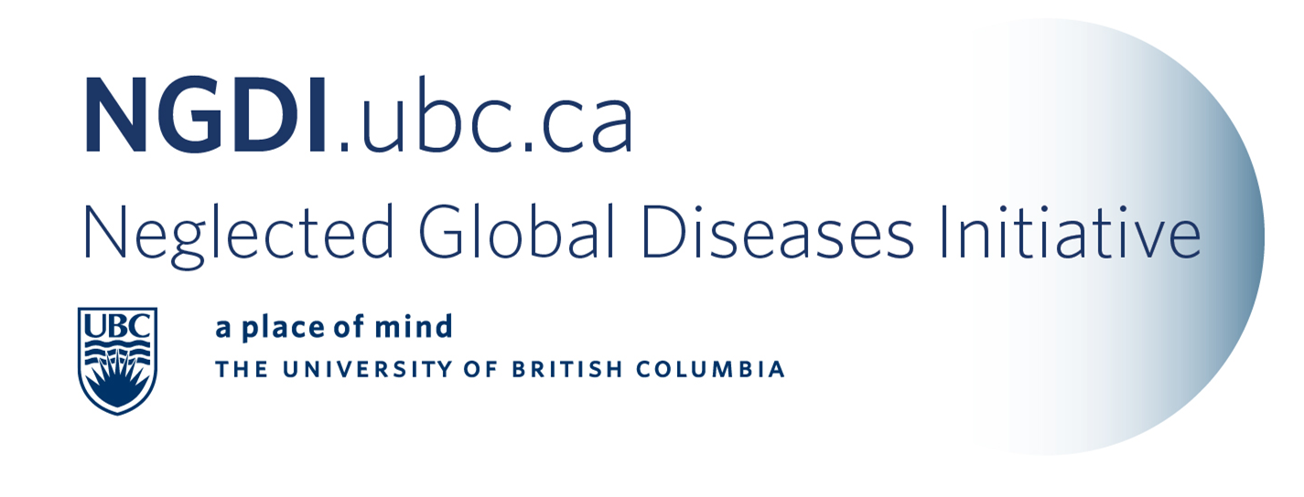

E-newsletter Contents: May 1, 2011

Member news
NGDI Member Update: Dr. Kishor Wasan
NGDI news
Dr. Ellen Wasan Adjunct Professor in Pharmaceutical Sciences featured at BCIT for outstanding research
Pharmaceutical Sciences provides NGDI with $30,000 Infrastructure funding
MITACS Presentation on May 6, 2011: Laurence Meadows
Distinguished Lectureship Seminar Series: Julio Montaner – May 13, 2011
Funding Opportunities
CIHR Knowledge Translation Grants
UBC Peter Wall Solutions Initiative
CIHR Pre-Announcement - Implementation Research on Hypertension in Low- and Middle- Income Countries
Global Commerce Support Program - Going Global Innovation
Africa Initiative Graduate Research Grant - May 31st Deadline
Saving Lives at Birth – Grand Challenge for Development May 6th Deadline Extention
Round 7 of Grand Challenges Explorations - Bill & Melinda Gates Foundation
Conferences
Rounds on International Surgery – Disability Surgeries
Branch for International Surgery talk – Dr. Atul Gawande – Location and Time change
News
General
Antibacterial Resistance
Malaria
Tuberculosis

Member News


NGDI Member Update: Dr. Kishor Wasan
In September, 2010 Dr. Kishor Wasan was inducted as a Fellow of the Canadian Academy of Health Sciences. The Canadian Academy of Health Sciences (CAHS) recognizes individuals of great accomplishment and achievement in the academic health sciences in Canada. The Academy provides timely, informed and unbiased assessments of urgent issues affecting the health of Canadians.

In April, 2011 he has been recognized as the recipient of the Canadian Society for Pharmaceutical Sciences Award of Leadership in Canadian Pharmaceutical Sciences for 2011. He will accept this award in late May at the general meeting.
[Top]

NGDI-UBC News
Dr. Ellen Wasan Adjunct Professor in Pharmaceutical Sciences featured at BCIT for outstanding research.
This article titled: BCIT Faculty member helps develop promising treatment for deadly tropical disease. Dr. Ellen Wasan is the lead author for the recent publication outlining the Oral AmB Projects tropically stable formulation.
Pharmaceutical Sciences provides NGDI with $30,000 Infrastructure Funding
The NGDI is pleased to announce the Faculty of Pharmaceutical Sciences has provided $30,000 for infrastructure support to the initiative. They have also set the NGDI fund as a priority project for subsequent donor funding. This funding has been further augmented by the in-kind office space and administrative support from the University-Industry Liaison Office and $5,000 support from the office of the Vice President Research and International. We thank all our sponsors for their generous support.
MITACS Presentation on May 6, 2011: Laurence Meadows
Laurence Meadows, Director of Business Development Vancouver will speak to interested faculty and students from 1:00 – 2:00 pm at the Michael Smith Laboratories Auditorium on May 6th, 2011.

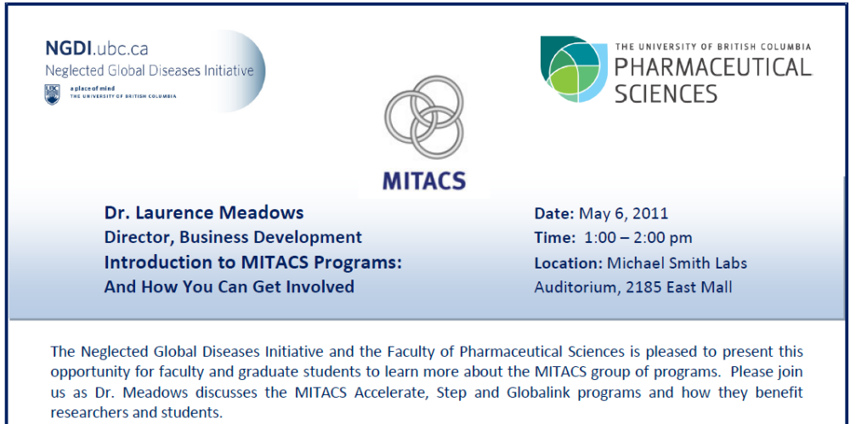

To distribute, download the full poster here.

[Top]
Distinguished Lectureship Seminar Series: Dr. Julio Montaner May 13, 2011
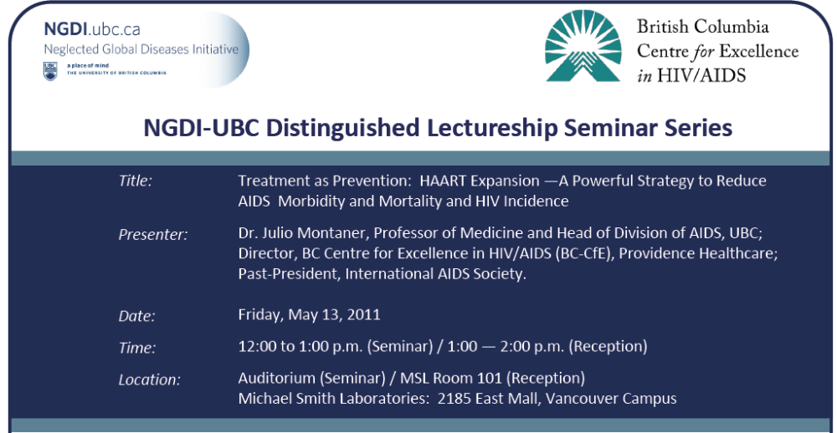
Download full poster.

[Top]

Funding Opportunities

CIHR Knowledge Translation Grants:

The following CIHR Grants have a deadline of June 15, 2011.

Meetings, Planning and Dissemination Grant: Knowledge Translation Supplement (Spring 2011 Competition) Total funding available for this grant round is $2,000,000 (20 grants) with a maximum 1-year funding of $100,000. There is an additional $100,000 for the following Priority Announcement: Health Services and Policy Research

Meetings, Planning and Dissemination Grant: Dissemination Events (Spring 2011 Competition)

Total funding available for this grant round is $125,000 (5 grants) with a maximum 1-year funding of $25,000. There is additional funding for the following priority announcement topics below:
A. CIHR Research Priority Areas:
- Ethics 2 additional $25,000 awards
- Gender, Sex, and Health 4 additional $25,000 awards
- HIV/AIDS 2 additional $25,000 awards
- Knowledge Translation 2 additional $25,000 awards
- Reproductive and Child Health 1 additional $25,000 award
  - Musculoskeletal Health, Arthritis, Skin and Oral Health 3 additional $25,000 awards
B. Research Related to CIHR Institute Mandates:
- First Nations, Inuit, and/or Métis Knowledge Dissemination Activities 6 additional $25,000 awards
- Infection and Immunity 1 additional $25,000 award
- Neurosciences, Mental Health and Addiction 1 additional $25,000 award
- Nutrition, Metabolism and Diabetes 1 additional $25,000 award

Meetings, Planning and Dissemination Grant: Planning Grants (Spring 2011 Competition)

Total funding available for this grant round is $125,000 (5 grants) with a maximum 1-year funding of $25,000. There is additional funding for the following priority announcement topics below:
A. CIHR Research Priority Areas:
- Aboriginal Health Research Priority Setting - Regional 12 additional $25,000 awards
- Aging 1 additional $25,000 award
- Cancer Research 1 additional $25,000 award
- Community-based Primary Healthcare 24 additional $25,000 awards
A major component of this Initiative is the launch of Team Grants in Community-Based Primary Healthcare.
- scaling up successful innovations in the use of technology, including electronic health records and mobile platforms, to improve the delivery of community mental health services;
- delivering prevention services to communities and populations in low and middle-income countries (LMICs).
- Ethics 2 additional $25,000 awards
- First Nations, Inuit and Métis Research Ethics Review 2 additional $25,000 awards
- Gender, Sex, and Health Research 4 additional $25,000 awards
- Health Services and Policy Research 2 additional $25,000 awards
- HIV/AIDS 2 additional $25,000 awards
  - $50,000 is available for each of the two funding streams relevant to this competition:
    - HIV/AIDS (biomedical/clinical research and health services/population health research); and
    - Community-based research (General and Aboriginal streams).
- Knowledge Translation 2 additional $25,000 awards
- Partnerships for Health System Improvement - Partnership Development Funds approx 5 additional $25,000 awards (total available $120,000)
- Reproductive and Child Health 1 additional $25,000 award
B. Research Related to CIHR Institute Mandates:
- Infection and Immunity 1 additional $25,000 award
- Nutrition, Metabolism and Diabetes 1 additional $25,000 award

UBC Peter Wall Solutions Initiative
For more information, please contact the PWSI Program Manager at pwsolutions@ubc.ca.
Click here to download a Call for Letters of Intent and an Application Form.
Deadline for LOI is May 31, 2011.

CIHR Pre-Announcement of RFA’s on Implementation Research on Hypertension in Low and Middle Income Countries
CIHR anticipates launching this competition in early May 2011 with applications being due early September 2011. The Canadian Institutes of Health Research (CIHR) joined by Canadian funding partners are pleased to announce their intention to release a Funding Opportunity on Implementation Research on Hypertension in Low and Middle Income Countries (LMICs). Investigators are invited to submit proposals to improve effective approaches to the prevention and control of hypertension. CIHR will be accepting applications for research in both LMICs and with First Nations, Metis and Inuit populations and communities. For full press release.

Global Commerce Support Program - Going Global Innovation:
Going Global Innovation (Going Global) is the innovation, science and technology pillar of the Global Commerce Support Program (GCSP). The GCSP provides a client focused consolidated approach for accessing funding sources from DFAIT in order to attract foreign direct investment, increase Canadian innovation and commercialization opportunities and to increase Canada's business share in foreign markets.
The objective of Going Global is to promote and enhance Canada's international innovation efforts by supporting Canadian companies and/or researchers in pursuing international R&D collaborative opportunities through the development of partnerships with key players in other countries/economies. For more information go to www.tradecommissioner.gc.ca/eng/science/going_global.jsp

Africa Initiative Graduate Research Grant - May 31st Deadline
The Africa Initiative Graduate Research Grant program supports short-term academic placements for students enrolled in a Master's or PhD program at select African universities.* The program offers grants of up to CAD$10,000 each to fifteen students per year to conduct research for up to four months at select Canadian universities.*

The program is building capacity by giving bright, highly-motivated students and scholars an opportunity to discover and impart new learning in a cross-cultural experience. Supported research covers the Africa Initiative thematic areas of conflict resolution, energy, food security, health, and migration, with special attention to the cross-cutting issues of climate change.

The Africa Initiative Graduate Research Grant program is currently accepting applications for research to be conducted between September and December, 2011.

The application deadline is May 31, 2011. For more information.
UBC Contact: Jacqueline Smit at 604-822-8136 or by email at jacqueline.smit@ubc.ca

[Top]
Saving Lives at Birth – Grand Challenge for Development
This announcement is open to the Canadian academic community. There are two funding tiers:
- Seed funding – up to $250K (up to 2 years)
- Transition Grants – up to $2 million (up to 4 years).

The extended application deadline is May 6th, 2011. More information is available at http://www.savinglivesatbirth.net/ or contact lyn.whitham@grandchallenges.ca
[Top]

Round 7 of Grand Challenges Explorations – Bill & Melinda Gates Foundation
Proposals for Round 7 of the Grand Challenges Explorations, a $100 million grant initiative to encourage innovation in global health research, are being accepted through May 19, 2011 at 11:30 a.m. Pacific Time.
The initiative offers scientists, inventors and entrepreneurs the opportunity to win $100,000 grants to pursue unconventional ideas that could transform health in developing countries, and focuses on research areas where creative, unorthodox thinking is most urgently needed.
[Top]

Conferences and Announcements

Rounds on International Surgery - Wednesday June 8th –5:30-7:00 pm
Venue: CESEI, Room 3600 (3rd Floor) Jim Pattison North-VGH
Global Disability in Surgical Care—Exploring the issues and challenges
Join speakers:
Dr Nancy Van Laeken, Chair, Dept of Surgery, Providence Health Centre and Associate Head of Surgery, UBC will discuss her recent visit to India with the International Confederation of Plastic, Reconstructive and Aesthetic Surgery
Dr. Norgrove Penny, a paediatric orthopedic surgeon based in Victoria, and Special Advisor for Physical Impairment, CBM International where he consults on the problems disabled people face in some of the world’s poorest countries.
The topic of this Round is timely. On June 9th the World Report on Disability will be launched by the WHO and the World Bank. The report will include the first update of WHO’s disability prevalence estimates for more than 30 years and provide analysis of what can improve the lives of people with disabilities. http://www.who.int/disabilities/world_report/en/index.html
Learning Objectives: 1) Increase understanding the burden of global disability and 2) Example of a plastics surgical response
The Branch for International Surgery – Dr. Atul Gawande talk
NOTE NEW TIME AND VENUE
Tuesday, May 10, 2011
Time: 3:00 – 4:00 pm Location: Diamond Health Centre, Lecture Theatre, Main Floor
No reservations necessary-first come basis

[Top]

Journals, Articles, Reports and News

General

HIV/AIDS: UNAIDS, activists urge countries to get clever with TRIPS, IRIN PlusNews
JOHANNESBURG, 17 March 2011 (PlusNews) - UNAIDS has released a new policy brief to help countries make intellectual property rights work for them, amid growing concern that an impending free trade agreement between the European Union (EU) and India could threaten the world's supply of generic antiretroviral (ARV) drugs.
The World Trade Organization's Trade Related Aspects of Intellectual Property Rights (TRIPS) allows countries to override patents - for public health purposes - by issuing "compulsory licenses" that enable the generic manufacture of drugs still under patent

New push to spur drugs for rare diseases, CTV News
WASHINGTON — Every other week, seven-year-old twins Addison and Cassidy Hempel have an experimental medicine injected into their spines in hopes of battling a rare, fatal disease. And it's their mom who made that possible. From her home in Reno, Nev., Chris Hempel persuaded scientists to share their research and managed to get the government to sign off on her daughters' unusual experiment. Hempel says getting help to fight a rare disease shouldn't be so hard.

But it's a huge challenge to generate drug company interest in the expensive testing of medicines for diseases so rare -- like her girls' Niemann-Pick Type C -- that the market is only a few hundred or few thousand people a year. There are treatments for just 200 of the roughly 7,000 rare diseases, illnesses that affect fewer than 200,000 people, and often far, far fewer. Yet add those diseases together, and more than 20 million Americans have one.
[Top]
Antimicrobial Resistance
Policy Package to Combat Microbial Resistance, WHO
This brief policy package was released by the WHO on World Health Day, 2011.
[Top]
Malaria

Seattle Biomed Nabs $9M Gates Foundation Grant to Speed Up Malaria Vaccine Effort, Xconomy, Seattle
Seattle Biomed isn’t wasting any time putting the whole systems biology idea to work.
The nonprofit global health research center is announcing today it has nailed down an $8.9 million grant from the Bill & Melinda Gates Foundation to use systems biology techniques to identify new biomarkers that could become building blocks for a new malaria vaccine. The grant will support work led by Seattle Biomed’s Ruobing Wang, Alan Aderem and Stefan Kappe, along with a crosstown collaborator from Sage Bionetworks—Jonathan Derry.

MalariaWorld is the world largest scientific and social network for malaria professionals with more than 6000 current subscribers from 110 countries.

One place for all your scientific information, publications, and discussions at www.malariaworld.org No more need to browse through e-tocs from journals and search for information. We collect everything for you and store it in one place.
Publish in our peer reviewed Open Access 2.0 MalariaWorld Journal (open access for readers AND writers).

For information and news on malaria join http://www.malariaworld.org/.

[Top]

